Semester Project Title:

**Covid-19 Tester and Vaccination Portal**

Members:

* L1f19bscs0276 Fareeha Amjad
* L1f19bscs0297 Iqra Tasawar
* L1f19bscs0284 Alishba Saeed

**CTVP**Is Nerve Centre to Synergize and Articulate Unified National Effort Against COVID-19.

The Centre Is One Window Operation to Collate, Analyze and Process Information Based on Digital Input and Human Intelligence. It also provides quarantine support and helping the patients in their vaccination trails in the best way.

**Phase 3:** Front End work

[**https://alishpkr20.wixsite.com/my-site-3**](https://alishpkr20.wixsite.com/my-site-3)

The above site can also be viewed on Cell phone as well as on PC. All the adjustments are made,

Tip: Do view the site on your cell phone!

---------------------------------------------------------------------------------------------------------------------------------

Data Requirements:

The major characteristics of the CTVP are….

1. The Portal has many **Domains** which are identified by the **Domain_id.** Each Domain has a unique domain name, and a particular doctor who manages the domain. Keeping track of the starting date of that particular doctor.
2. Each domain has **Doctors.** Each doctor is assigned to attend a particular age group. He also has to collect the medical record and evaluate his/her health and direct him to **specialists.**  Where, a general doctor is identified by **doctor_id** and a specialist by **specialist_id.**
3. A **Patient**  must register to appear in the **waitingList.** Each Patient has a name, age, gender, date of birth, address. Only Infected patients can connect to the specialists. WaitingList must contain the age group and cnic of the patient. We want to keep track of the vaccine dose a patient has received.
4. Cnic for a patient of a waitingList is unique.
5. **QuarantineSupport**  enables the patient suffering from the virus to be monitored by the specialists, also allowing them to observe their health after being infected.
6. **Patients** in waitinglist should be vaccinated by a vaccine which is identified by a unique id, unique name, country of production, it’s expiry date , duration, it’s temperature to be stored at. We should also know the no. of doses produced of a particular vaccine.
7. A patient vaccinated is entered in **CheckOUT** along with the cnic, vaccine type, dose number, date ,time and location of being vaccinated.
8. A **managing team** must manage the count of citizens being vaccinated from a particular province. Where, province name is unique and is identified by a **province_id.**

-------------------------------------------------------------------------------------------------------------------------------

Entity Relation Diagram:

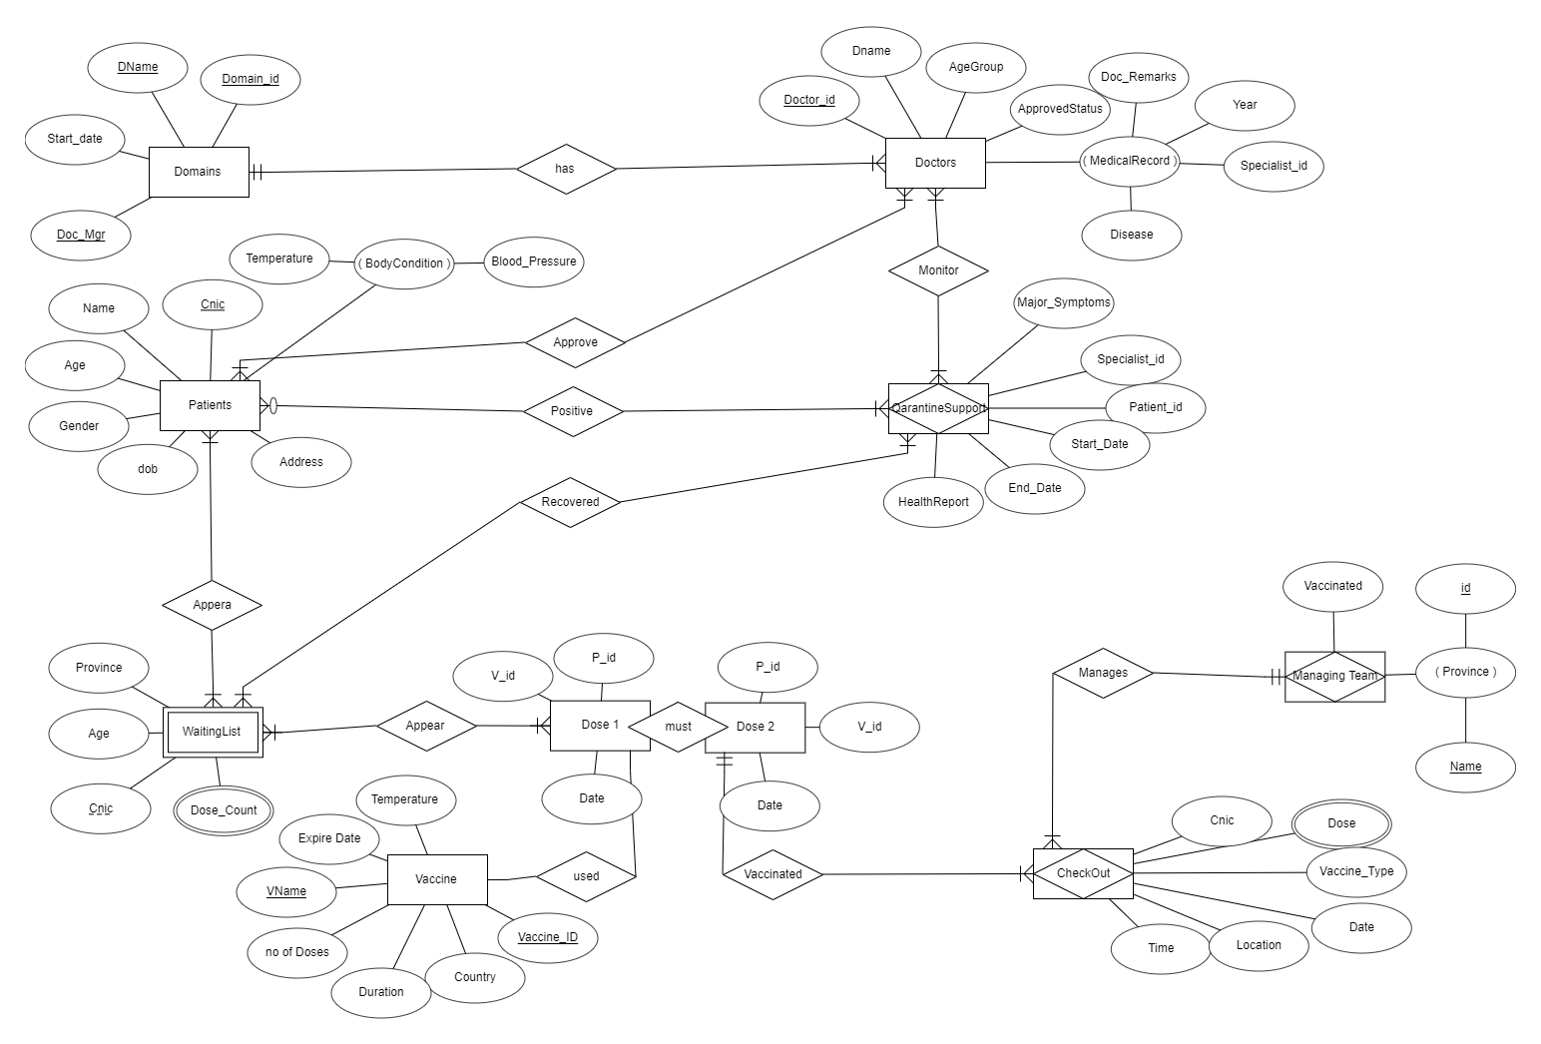

-------------------------------------------------------------------------------------------------------------------------------

ER Relations:

**--------------------------------------------------------------------------------------------------------------------**